The New Model Armies
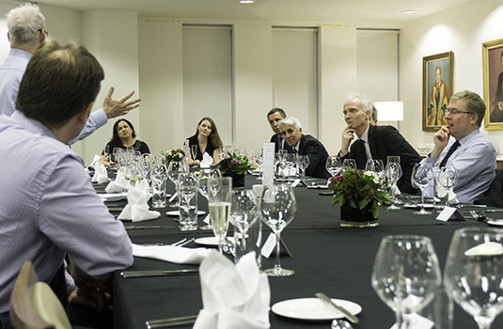
Left to right: Dr Justin Wilson, Professor Sir Simon Wessely, Melanie de Smith, Holly Taggart, Peter Spilsbury, Stephen Firn, Ben Dyson, Richard Murray
In my last blog I told you all about RCPsych’s calls to the next government in Five Steps to Fairness, on the need for a bigger mental health workforce. By the end of today we should have seen the manifestos from all the main parties, but in the meantime we already know that Theresa May already is pledging to increase the mental health workforce by 10,000.
Nothing wrong with that. We are calling for more mental health staff. Naturally, rumours persist that this 10,000 won’t really be ten thousand, after staff changes in recent years are accounted for and the possibility that some of these numbers may be voluntary roles. And who is going to pay for this?
We need to make sure that the posts of some of the most skilful members of the workforce are not mortgaged off to swiftly train up people who with the best will in world will not be able, or indeed allowed, to help the most severely ill, and the most complex. We will fight our corner on this one. As I’ve said before, when it comes to helping people with mental ill health, it isn’t about expensive kit, it’s about staff, highly trained, in the right numbers, how they work, where they work, the teams they work in and how they feel.
And those teams are beginning to change right across the NHS. Our report, published today, Mental health and new models of care: Lessons from the Vanguards examines new ways of doing things that aim to move care out of hospitals and into the community, reducing traditional divides to deliver care that treats mental, physical and social needs together.
In what has been a leitmotif of these blogs, at least when they are about the NHS, your knowledge of these developments may be sketchy. Mine is. This is not helped by the fact that as ever they are disguised by a complex system of codes that would have baffled the people who broke the Enigma codes - NCM, MCP, PAC etc. I sometimes think there is a computer in the basement of NHS England that produces random three letter sequences, and then it is the task of the officials to produce plans to fit the acronyms, rather than the other way round.
But when it comes to transforming care, we are not just in the vanguard, but we are the vanguard of the vanguards.^{i} We have done a lot of this. More than any other part of the NHS. Deinstitutionalising services, moving care out of hospitals into the community through the care programme approach, care coordination and investing in crisis care home resolution treatment teams. We did the lot. We transformed ourselves from an almost entirely hospital based service to one that is now the opposite. No one else has achieved anything remotely similar. It wasn’t without its problems, but we got there. So we know of what we speak.
And so common sense would dictate that as the rest of the NHS seeks to transform, they would look to us, the vanguard of vanguards, for a tip or two. But have they?^{ii}
Through our work, jointly with the King’s Fund, we’ve found that some areas have made great advances to include mental health but have been disappointed that some others barely considered the sector at all. The bulk of mental health plans within new models of care revolve around enhanced models of primary care, with mental health expertise directly embedded into primary and community health teams. For this we can see a common and distinct move of specialists, including psychiatrists, out of hospitals and into the community, and teams of mental health nurses and allied health professionals with them. It's not new – indeed, one Geraldine Strathdee, soon to be our latest Honorary Fellow, started her career doing just that.
Nothing radical in this. It’s what we believe – adhering to a biopsychosocial approach based on multidisciplinary working. So it’s nice to see new exemplars in action. In West Cheshire Way, an older people’s consultant psychiatrist post has been created to provide educational input into the integrated care teams and primary care. This supports RCPsych’s manifesto ask that not only do we need more psychiatrists but we need a greater understanding of mental health across the wider NHS workforce. In Tower Hamlets, mental health nurses in the integrated community health team have protected time to provide training to primary care as well as community health teams.
Putting mental health expertise in places where most people access services is likewise bread and butter to us. That’s exactly why I went into Liaison Psychiatry many years ago. Now in Tower Hamlets and elsewhere mental health nurses are working within integrated teams, as opposed to community or acute mental health services. Many of the vanguards sites are starting with older people’s health services. Quite right too – says someone who has just got their bus pass (BUT NOT RETIRING!).
But despite these positive steps, our overall assessment is that opportunities to integrate mental health into new models of care have not been fully realised. The level of priority given to mental health has just not been high enough. Sometimes we are an afterthought, picked up after checking in the rear view mirror, other times we don’t even make it on to the pitch.
Does this matter? Very much so. Because if the vanguards are at the front of the line, what is coming behind is the main force. These are the sustainability and transformation plans or “STPs”, which I have droned on about before. And we need to make sure that the omissions by the vanguards are not repeated when the main army takes the field.
Ah, I hear you say, surely these new things have been evaluated. Everything is evaluated these days. Indeed so, but there are evaluations and…er…evaluations. And in the evaluations of the vanguard sites mental health is conspicuous by its absence. Plenty of good things being measured, but none are specific to mental health.
So we are asking that future evaluation includes the impact of this latest New Model Army of new care models on people with mental health problems. And continuing the Cromwellian analogy, leaders must not be cavalier with mental health – and need to be seen to take account of good practice where the gold standard (with mental health support successfully embedded in integrated care teams, enhanced models of general practice, and urgent and emergency care pathways) has been achieved. Until then, we will follow another acronym, this time introduced by Ronald Reagan when he was negotiating the end of the Cold War with Mikhail Gorbachev. TBV. Trust But Verify.
[i] Pedanticus, in what may be his last message to you, notes that “vanguard” is actually a French word, derived from avant garde, meaning the front of the line. Once a military term, it is now more often used in art and culture. But as the Pub Landlord would point out, either way it is French, and now that Brexit means Brexit, surely we should find a good Anglo Saxon word instead. Arrow Fodder perhaps?
[ii] Pedanticus reminds me that is a rhetorical question. And as Pedanticus takes his final bow, a round of applause please. I would be lost without his belief that getting the facts right, no matter how trivial, matters.
Professor Sir Simon Wessely

