Chronic Fatigue Syndrome
Simon Wessely

TermInology

Doctors in many specialties regularly see patients with severe fatigue as a principal complaint associated with other somatic symptoms and considerable disability, but with no clear-cut biomedical diagnosis. A variety of terms are used to describe these patients; prominent bowel symptomatology in an individual attending a gastroenterology clinic may be diagnosed as ‘irritable bowel syndrome’, but if muscle pain is severe a rheumatologist may use the term ‘fibromyalgia’. ‘Effort syndrome’ and ‘neurasthenia’ were also common diagnoses.
Recently, the terms ‘myalgic encephalomyelitis’ (ME) and ‘post-viral fatigue syndrome’ have been used, but both are unsatisfactory. ‘ME’ was introduced after the still controversial epidemic illness that closed the Royal Free Hospital, London, UK, in 1955, but this term is best avoided; the features of that episode were not those of a chronic fatiguing illness, and ‘encephalomyelitis’ refers to a distinct neuropathological process which is never present. ‘Post-viral fatigue syndrome’ is preferable, but the term implies that all cases occur after a viral illness, which is not true.
Overall, there is little evidence of any essential differences between these conditions. The current international consensus is the term ‘chronic fatigue syndrome’ (CFS), which is both short and accurate.

Aetiology

The aetiology of CFS remains uncertain. Considerable attention has been given to immunological and virological explanations. Some patients show immunological abnormalities (e.g. increased memory cells, low levels of natural killer cells, cytokine activation), but these are inconsistent, and do not appear to effect outcome.
The role of infection is unclear. CFS can occur after viral, bacterial or other infections, but the risk is increased after

Simon Wessely is Professor of Epidemiological and Liaison Psychiatry at GKT School of Medicine and Dentistry, London, UK, and the Institute of Psychiatry London. He qualified in medicine from the University of Cambridge and the University of Oxford, and worked in general medicine in Newcastle upon Tyne. He trained in psychiatry at the Maudsley Hospital and the National Hospital for Neurology and Neurosurgery, London, and in epidemiology at the London School of Hygiene. His research interests include the nature, epidemiology and treatment of chronic fatigue syndrome, and the other unexplained syndromes, such as Gulf War related illness

certain infections, particularly with Epstein—Barr virus. Such syndromes are usually self-limiting, however, and are unlikely to be a major risk factor for abnormal fatigue of longer than 6 months’ duration. The evidence for links between CFS and the enterovirus family is unconvincing; many findings may be artefacts of study design or reflect a nonspecific stressor.
The factor which precipitated the illness is not usually the same as that which perpetuates it. There is no compelling evidence for viral persistence in CFS, and analogies with HIV infection are inappropriate. Instead modern thinking sees the infective agent as a trigger, analagous to a “hit and run” accident, rather than a continuing focus of infection.

Risk factors

Although CFS is a heterogeneous condition of obscure origin, certain factors are known to increase the risk of developing the illness.
• CFS is more common in patients who have had previous psychiatric illness.
• Encephalitic illnesses, and perhaps other causes of central nervous damage, may predispose to CFS.
• Lack of physical fitness, which is an important variable in previously fit people who are forced into inactivity, may have a role in perpetuating CFS.
Although many patients seen in specialist clinics conform to certain stereotypes (e.g. high-achieving, perfectionist individuals of higher social class), this may be related more to selection bias and illness attribution than to the nature of CFS.

Psychiatric illness and CFS

The symptoms of CFS overlap with those of several psychiatric disorders.
Most depressed patients report substantial fatigue, and for some it is the most distressing part of the illness. Fatigue is one of the most common presenting symptoms in depression — in primary care, patients present as often with tiredness as with the more characteristic symptoms of affective disorder. Other conditions in which fatigue has a prominent role include anxiety disorders (with or without hyperventilation), somatization disorder, eating disorders and alcohol abuse.
Most patients who fulfil the criteria for CFS seen in specialist care also fulfil criteria for a variety of psychiatric illnesses (Figure 1). The greater the number of somatic symptoms, the greater the risk of psychiatric disorder. This psychological morbidity is often missed. Some patients are reluctant to discuss emotional issues, and most prefer to receive physical rather than psychological diagnoses. Conversely, many specialists are unfamiliar with, and occasionally unwilling to consider, psychological diagnoses (false negatives). Such cases of ‘hidden’ psychiatric morbidity may reflect the perceived stigma of psychiatric illness. Conversely, psychiatric labels can also be inappropriately applied (false positives).
The precise role of psychiatric disorder in CFS remains unclear. Psychiatric illness is occasionally a consequence of physical illness, but this does not explain the higher rates of psychiatric disorder found in patients with CFS compared to other chronic illnesses. In some patients, CFS and psychiatric disorder have a common neurobiological origin. Recent work has highlighted subtle alterations in the functioning of the

hypothalamic—pituitary axis in CFS. There is reasonable evidence that in a a subgroup of patients with CFS (those without evidence of major depression) there is evidence of an underactive hypothalamopituitary-adrenocortical system, contrasting with the classical overactive pattern seen in severe depression. Typically, major depression is characterized by insomnia and anorexia, but some patients with CFS report hypersomnia without major disturbance in appetite. A few authorities now classify CFS as a form of atypical depression.

Clinical features

There are no diagnostic signs or symptoms of CFS. A variety of symptoms (e.g. post-exertional fatigue or myalgia, difficulties with concentration and short-term memory, subjective changes in temperature) have been claimed to be specific, but such findings have not been substantiated. The diagnosis of CFS is made in an individual with excessive physical and mental fatigue brought on by physical or mental effort, and with associated functional disability, for which a conventional ‘biomedical explanation cannot be found,
Fatigue in CFS is central rather than peripheral in origin. Patients are not abnormally fatiguable (if fatigue is measured neurophysiologically as an inability to sustain power) and neuromuscular function is usually normal. There is little evidence to suggest that the fatigue results from impaired motivation, and the use of terms such as ‘malingering’ or ‘hysteria’ is to be deplored. As in depression or multiple sclerosis, the fatigue in CFS is a subjective experience (rather than the objectively measurable fatigue of neuromuscular illnesses such as myasthenia gravis) and can be appreciated (and measured) only at first hand.

Sufferers may complain of severe symptoms of cognitive dysfunction (clinical evidence that by itself makes a neuromuscular origin of the symptoms unlikely), but this is not reflected in the results of formal studies of neuropsychological function. Most memory functions are normal, though evidence is emerging of problems in selective attention. CFS may thus be associated with a disorder of effortful cognition, rather than any actual deficits in recall, just as it is associated with an increased sense of motor effort, rather than any objective deficits in neuromuscular function.

Investigations

CFS is a nonspecific illness that can be mimicked by a number
of uncommon conditions; for example:
• Lyme disease
• multiple sclerosis
• toxoplasmosis
• lymphoma.
Coeliac disease
CFS is therefore a diagnosis of exclusion, though it is unnecessary to exclude every cause of fatigue in every chronically tired
person.
In individuals with fatigue lasting more than 6 months, physical examination, basic laboratory tests (full blood count, ESR, electrolytes, liver and thyroid function) and a good psychosocial history and examination will usually establish the diagnosis (Figure 2). Unless physical or laboratory examination reveals significant abnormalities, the yield from further, sophisticated tests is low and there is a risk of iatrogenic injury.
Psychiatric disorders can be identified by appropriate questioning, are potentially treatable, and adversely affect outcome if missed; therefore, all patients in whom CFS is suspected must

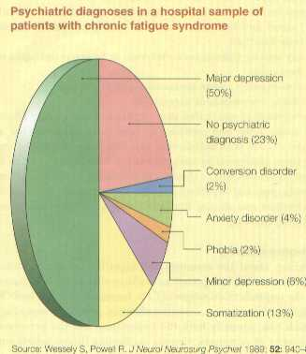 | 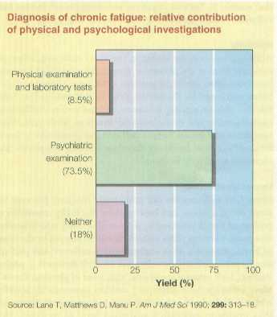

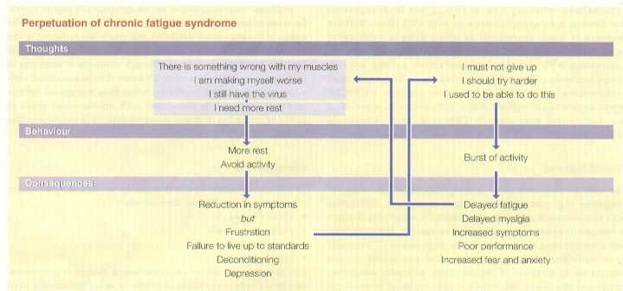

3

be screened routinely for psychological illnesses. All patients in whom CFS is suspected should have a routine mental state examination.

Cognitive and behavioural factors in chronic fatigue syndrome

Recently, attention has moved from unitary models of CFS (a single agent causes a single disease), to more complex, multifactorial approaches which involve a distinction between factors that trigger the illness (e.g. glandular fever) and those that sustain it. Various cognitive and behavioural factors may influence chronicity and impede recovery (Figure 3).

Inactivity
Although rest may be useful in the short term (e.g. when recovering from acute glandular fever), the prolonged rest and inactivity often found in patients with long histories of CFS (sometimes reinforced by the advice given to sufferers) is less helpful. Rest reduces activity tolerance, and has profound effects on cardiovascular and neuromuscular function. With time, more symptoms and greater fatigue will occur at progressively lower levels of exertion. Inactivity therefore sustains symptoms, and increases sensitivity to them.

Inconsistent activity
Many CFS sufferers are not profoundly inactive, but may instead adopt a ‘boom and bust’ pattern. Typically, excessive or prolonged rest is followed by a burst of activity which is often ‘too much, too soon’. This pattern may be reinforced by the sense of frustration that is often encountered in sufferers, and perhaps also by pre-existing personality and lifestyle factors (e.g. perfectionism, high internal standards, high level of physical fitness). Most sufferers have attempted sudden increases in activity, which culminate in exhaustion and further rest. Sufferers are thus unable to establish a sustained level of recovery. This pattern often leads to the characteristic complaint of CFS sufferers, that any activity must be ‘paid for’ later by further pain and fatigue.
Delayed fatigue and myalgia are well-recognized physiological phenomena that occur 24—48 hours after any exertion in excess of a sufferer’s current (and not previous) fitness, and may be caused by eccentric muscle contractions leading to local microtrauma in muscles subjected to excess work (as occurs in anyone undertaking exertion after a period of inactivity).

Illness beliefs and fears about symptoms
Illness beliefs and fears about symptoms can influence disability, mood and behaviour in many conditions of varying origin, and CFS is no exception. In CFS, unhelpful illness beliefs include fear that:
• any activity that causes an increase in fatigue is damaging or impossible
• over-exertion causes permanent muscle damage
• CFS is irreversible or untreatable.
The strength of conviction that symptoms have a solely physical cause is associated with poor outcome, perhaps because it is linked to beliefs about the harmful effects of exercise. In the initial stages of CFS, such beliefs may fuel avoidance of activity, and are often reinforced by each successive aversive experience of exercise-related fatigue, leading to increasing restrictions. Conversely, personal expectations about ‘not giving in’ may lead to inadequate rest during the initial stages of the illness, thus delaying recovery.

Symptom focusing
Concern about the meaning and significance of symptoms (which are often interpreted as ‘warning signals’) is heightened by the unpredictable nature of CFS. Increased concern leads to heightened awareness, selective attention and ‘body-watching’, which can intensify both the experience and the perceived frequency of symptoms, thereby confirming illness beliefs and reinforcing avoidant behaviour.

Planning rest and activity in chronic fatigue syndrome

• First stabilize activity and rest
• Make rest predictable by timetable, and not according to symptoms
• Develop a programme of predictable and regular activity
• Choose goals that are currently avoided but are enjoyable
• Choose targets not distances
• Warn about temporary symptom exacerbation
• Choose targets with regard to current fitness and activity levels, not past fitness or activity
• Prevent excess activity on ‘good’ days
• Do not prevent activity on ‘bad’ days
• Expect improvements to take weeks, not days
• Always encourage rehabilitation/management, and not ‘cure’

Source: Wessely S. Primary Care Psychiatry 1995;
1: 87—1 05.

4

intervention is made, it is essential that sufferers feel that they have been listened to, and that their symptoms and disability are believed. A firm and confident diagnosis of CFS is an important part of engagement and is usually necessary before treatment can proceed.

Planning rest and activity: once mutual trust has been established, it may be possible to begin a more structured rehabilitation programme. Cautious increases in activity may combat physical deconditioning and psychological helplessness. Over-zealous counselling of rest can prolong a cycle of inactivity, fatigue, pain and depression. Simply prescribing exercise can be counterproductive, however, and if exercise is undertaken to excess it may cause delayed fatigue and myalgia, leading to demoralization and loss of confidence in the physician. The initial level of activity must be set sufficiently low to be attainable.
The planning of rest is as important as activity. Immediate reductions in the amount of rest taken are seldom advised in the early stages. The amount of rest should be predetermined, and not taken in response to symptoms. The initial goal of treatment is to combat the unpredictability of symptoms and establish consistency before advising cautious increases in activity. The aim is to avoid the handicapping, stimulus-driven cycle of CFS, in which symptoms are always a signal to rest, and to replace previous sensitization by tolerance.
Practical hints are listed in Figure 4.

Emotional consequences
For some patients with CFS, depression may be the primary cause of ill health, but for others depression may arise during the illness, together with anxiety, frustration and boredom. Depression and anxiety are associated with fatigue and muscle pain, impaired memory and concentration, and reduced activity.

.

Treatment

There is no specific treatment, though a variety of agents have
been tried.

Antiviral drugs: various antiviral drugs, or agents acting on the immune system, have been tested, but none can be recommended at present.

Nutritional supplements are popular; there is no sound rationale for their use, but they may have a place if they are cheap and free from side-effects.

Antidepressants are successful in the related condition of fibromyalgia, and should be used in patients with depressive features. Antidepressants may also have a direct effect on fatigue and myalgia independent of mood disorder, but this is not yet established.

Cognitive behaviour therapy (CBT) and Graded Exercise Therapy (GET) are currently the two approaches with the strongest evidence base, and are considered further in the final section

Rehabilitation
Rehabilitation remains the mainstay of treatment. It is essential to engage the patient in a rehabilitative strategy and to form a therapeutic alliance. This may not be easy if one enters into a dispute with patients about the origins of symptoms, and is both unnecessary and counter productive. Many patients are sensitive to any suggestion that their symptoms or disability is anything less than authentic, and suspicious of approaches that might be viewed as ‘psychological’.

FURTHER READING

Anon (1996). Chronic Fatigue Syndrome: Report of a Committee of the Royal Colleges of Physicians, Psychiatrists and General Practitioners. London, Royal Colleges of Physicians.

Anon (2001). Report of the Working Party on CFS/ME to a Chief Medical Officer for England and Wales. London, Department of Health.

Anon (2002). "Interventions for the management of CFS/ME." Effective Health Care Bulletin 7(4). http://www.york.ac.uk/inst/crd/ehc74.htm

Campling, F. and M. Sharpe (2000). Chronic Fatigue Syndrome: the Facts. Oxford, Oxford University Press.

Wessely, S., C. Nimnuan, et al. (1999). "Functional somatic syndromes: one or many?" Lancet 354: 936-939.

Wessely S, Hotopf M, Sharpe M. Chronic Fatigue and Its Syndromes. Oxford University Press, 2000.

